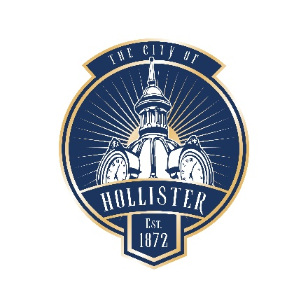

NOTICE OF CANCELLATION

HOLLISTER PARKS AND RECREATION ADVISORY COMMISSION
375 Fifth Street, Hollister CA 95023
City Hall

Notice is hereby given that the regular meeting of the City of Hollister Parks and Recreation Advisory Commission scheduled for January 28, 2025, has been canceled.

The next regular meeting will be held on Tuesday, February 25, 2025, at 6:30 p.m. in the City Council Chambers at Hollister City Hall, 375 Fifth Street, Hollister, CA 95023.

This notice for the Art and Culture Commission of the City of Hollister was posted on the bulletin board at City Hall on January 10, 2025, per Government Code Section 54954.2

